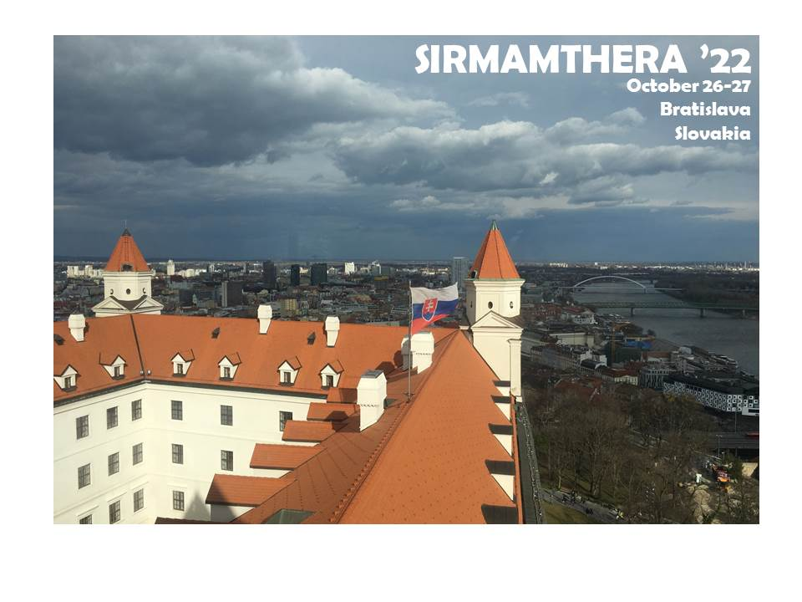

Under the support of



and administered by



the Biomedical Research Center, Slovak Academy of Sciences



organizes symposium

**Mitochondria-associated membranes as therapeutic target in rare neurodegenerative diseases**

SIRMAMTHERA’22

on October 26-27th, 2022 in Bratislava, Slovakia

**Venue**

* Bratislava, the capital city of Slovakia, Hotel Devin****

**Scientific sessions**

* Wolfram syndrome
* Amyotropic lateral sclerosis
* familial Parkinson’s disease
* Harel-Yoon syndrome
* Sigma 1 receptor
* Membrane contact sites
* Signalling & Processes

**Confirmed speakers**

* Geert Bultynck, KU Leuven, Leuven, Belgium
* Michal Cagalinec, Biomedical Research Center, SAS, Bratislava, Slovakia
* Angela Cenci Nilsson, Lund University, Lund, Sweden (online)
* Vinay Choubey, University of Tartu, Tartu, Estonia
* Benjamin Delprat, Université de Montpellier, Montpellier, France
* Barbara E Ehrlich, Yale University, New Haven, USA
* Tamar Harel, Hadassah Medical Center, Jerusalem, Israel (online)
* Matej Hotka, Medical University of Vienna, Vienna, Austria
* Nolwen le Floch, French Wolfram Syndrome Association, France (online)
* Jean-Charles Lievens, Université de Montpellier, Montpellier, France
* Tangui Maurice, Université de Montpellier, Montpellier, France
* Patricia Melnyk, Liile University, Lille, France (online)
* Marco Peviani, University of Pavia, Pavia, Italy (online)
* Elodie Richard, INSERM, Montpellier, France
* Jan Skoda, St. Anne’s University Hospital, Brno, Czech Republic
* Martina Skopkova, Biomedical Research Center, SAS, Bratislava, Slovakia
* Pauline Tarot, INSERM, Montpellier, France
* Catherine Verfaillie, KU Leuven, Leuven, Belgium
* Alexandra Zahradnikova Jr, Biomedical Research Center, SAS, Bratislava, Slovakia
* Liga Zvejniece, Latvian Institute of Organic Synthesis, Riga, Latvia

**Organizers**

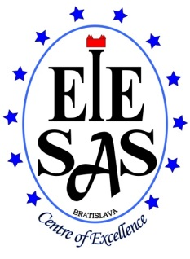  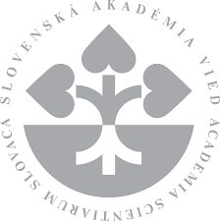

Institute of Experimental Endocrinology, Biomedical Research Center,

Slovak Academy of Sciences, Bratislava, Slovakia

**Chair**

Michal Cagalinec

**Steering committee**

Daniela Gasperikova, Martina Skopkova

**Members**

Iullia Baglaeva, Silvia Borecka, Zuzana Ceplikova-Vetrecin, Zuzana Dobiasova, Marian Grman, Dominika Hromnikova, Marek Sklenar, Terezia Valkovicova, Alexandra Zahradnikova Jr

**Webpage administration and online streaming**

Bogdan Iaparov

October 26, Wednesday

8:30-8:45 Opening

**Session 1: Wolfram syndrome**

*Chair: Michal Cagalinec*

8:45-9:15 **Nolwen Le Floch**, France (online)

*French Wolfram Syndrome Association – The families fight*

9:15-9:45 **Benjamin Delprat**, France

*Wolfram syndrome: from physiopathology to therapy*

9:45-10:00 **Elodie Richard**, France

*NCS1 overexpression restores mitochondrial activity and behavioral alterations in a zebrafish model of Wolfram syndrome*

10:00-10:30 **Catherine Verfaillie**, Belgium (online)

*Some but not all WFS1 iPSC-derived oligodendrocytes show extensive UPR stress: is there a MAMs phenotype?* (cancelled)

10:30-11:00 Coffee break

**Session 2: Amyotropic lateral sclerosis**

*Chair: Benjamin Delprat*

11:00-11:30 **Jean-Charles Lievens**, France

*Sigma-1 receptor as a therapeutic target in amyotrophic lateral sclerosis*

11:30-11:45 **Pauline Tarot**, France

*Sigma-1 receptor as a therapeutic target in amyotrophic lateral sclerosis, part II*

11:45-12:00 **Catherine Verfaillie**, Belgium (online)

*Patient derived FUS mutant vs isogenic ALS oligodendrocytes, as well as oligodendrocytes created by knock-in of a FUS mutation in normal iPSC display abnormal lipidomics and UPR stress typical for defective MAMs* (cancelled)

12:00-12:30 **Marco Peviani**, Italy (online)

*Tackling ALS by exploring Sigma-1 receptor and TSPO ligands at the crossroad between neurodegeneration and neuroinflammation*

12:30-14:00 Lunch

**Session 3: familial Parkinson’s disease**

*Chair: Geert Bultynck*

14:00-14:45 **Angela Cenci Nilsson**, Sweden (online)

*Evaluation of Sigma-1 receptor ligands in a mouse model of Parkinsonism*

14:45-15:15 **Vinay Choubey**, Estonia

*A novel role of Keap1/PGAM5 complex in Pink1-Parkin induced mitophagy*

15:15-15:45 Coffee break

**Session 4: ATAD3A-associated disorders**

*Chair: Daniela Gasperikova*

15:45-16:40 **Tamar Harel**, Israel (online)

*Genotype-phenotype correlations at the ATAD3A locus*

16:40-16:55 **Shlomit Ezer**, Israel

*In vitro and in vivo models of ATAD3A-associated disorders*

16:55-17:10 **Martina Skopkova**, Slovakia

*Phenotypic, biochemical and microscopic characterization of patients with biallelic mutations in the ATAD3A gene*

17:15-18:45 Round table (closed session)

19:15- Gala Dinner (Hotel Devin)

October 27, Thursday

**Session 5: Sigma 1 receptor**

*Chair: Jean-Charles Lievens*

9:00-9:30 **Tangui Maurice**, France

*The importance of Sigma-1 receptor in physiopathological brain plasticity*

9:30-10:00 **Patricia Melnyk**, France (online)

*Safe and efficient Sigma1 ligand: a potential drug candidate for Multiple Sclerosis*

10:00-10:30 **Liga Zvejniece**, Latvia

*Metabolomic Signatures of Sigma-1 Receptor Knockout Mice*

10:30-11:00 Coffee break

**Session 6: Membrane contact sites**

*Chair: Tangui Maurice*

10:00-11:45 **Geert Bultynck**, Belgium

*Intracellular Ca2+ dynamics and its modulation by BCL-2 family and CISD2*

11:45-12:15 **Michal Cagalinec**, Slovakia

*Microscopic approach to assess mitochondria-ER interaction*

12:15-12:30 **Jan Skoda**, Czech Republic

*ER–mitochondria connectivity controls multidrug resistance in neuroblastoma*

12:30-14:00 Lunch

**Session 7: Signalling & Processes**

*Chair: Liga Zvejniece*

14:00-14:45 **Barbara Ehrlich**, USA

*Calcium signalling in Wolfram Syndrome and other neurodegenerative diseases*

14:45-15:15 **Matej Hotka**, Austria

*Ca2+-dependent stimulation of mitochondrial ATP synthesis in primary hippocampal neurons*

15:15-15:30 **Alexandra Zahradnikova Jr**, Slovakia

*Cardiac calcium signalling - the role of dyadic junction*

15:30-16:30 Coffee break and poster presentation

17:00-18:30 Sightseeing

19:00- Dinner (Hotel Devin)

List of Poster Presentations

P1: **Dagan S.Y.**, Ezer S., Frumkin A., Lupski J.R., Harel T.

*Implications of ATAD3A Paralogs on CRISPR/Cas9 Gene Editing*

P2: **Baglaeva I.**, Iaparov B., Zahradnikova A. Jr, Zahradnik I., Zahradnikova A.

*Automated analysis of noisy calcium transients in cardiac myocytes*

P3: **Iaparov B.**, Baglaeva I., Zahradnik I., Zahradnikova A.

*Magnesium ions determine spontaneous calcium activity in cardiomyocytes*

P4: **Sklenar M.**, Borecka S., Cagalinec M., Skopkova M., Gasperikova D.

*Functional study of the novel deletion variant in the WFS1 gene*

P5: **Rambani V.**, Kolnikova M., Cagalinec M., Skopkova M., Gasperikova D.

*Novel PMPCA variants in Leigh syndrome*

P6: **Kabelikova P.**, Ivovic D., Kosnacova H., Wagner A., Goffova I., Jurkovičova D.

*Alterations of mitogenome and mitochondrial dynamics in chemoresistant testicular cancer cells*

List of Participants

|  |  |
| --- | --- |
| **Name** | **Affiliation, email** |
| Iuliia Baglaeva | Institute of Experimental Endocrinology  Biomedical Research Center, Slovak Academy of Sciences  Bratislava, Slovakia  Email: [ueenjuli@savba.sk](mailto:ueenjuli@savba.sk) |
| Silvia Borecka | Institute of Experimental Endocrinology  Biomedical Research Center, Slovak Academy of Sciences  Bratislava, Slovakia  Email: [silvia.borecka@savba.sk](mailto:silvia.borecka@savba.sk) |
| Geert Bultynck | Laboratory of Molecular and Cellular Signaling  KU Leuven  Leuven, Belgium  Email: [geert.bultynck@kuleuven.be](mailto:geert.bultynck@kuleuven.be) |
| Michal Cagalinec | Institute of Experimental Endocrinology  Biomedical Research Center, Slovak Academy of Sciences  Bratislava, Slovakia  Email: [michal.cagalinec@savba.sk](mailto:michal.cagalinec@savba.sk) |
| Angela Cenci Nilsson | Basal Ganglia Pathophysiology Laboratory  Lund University  Lund, Sweden  Email: [angela.cenci_nilsson@med.lu.se](mailto:angela.cenci_nilsson@med.lu.se) |
| Vinay Choubey | Department of Pharmacology  University of Tartu  Tartu, Estonia  Email: [vinay.choubey@ut.ee](mailto:vinay.choubey@ut.ee) |
| Shira Dagan | Goldyne Savad Institute of Gene Therapy  Hadassah-Hebrew University Medical Center  Jerusalem, Israel  Email: [shira.dagan@gmail.com](mailto:shira.dagan@gmail.com) |
| Benjamin Delprat | Molecular Mechanisms in Neurodegenerative Dementia  EPHE INSERM  Montpellier, France  Email: [benjamin.delprat@inserm.fr](mailto:benjamin.delprat@inserm.fr) |
| Ankit Dhoundiyal | Center for Physiology and Pharmacology  Medical University of Vienna  Vienna, Austria  Email: [ankit.dhoundiyal@meduniwien.ac.at](mailto:ankit.dhoundiyal@meduniwien.ac.at) |
| Zuzana Dobiasova | Institute of Experimental Endocrinology  Biomedical Research Center, Slovak Academy of Sciences  Bratislava, Slovakia  Email: [zuzana.dobiasova@savba.sk](mailto:zuzana.dobiasova@savba.sk) |
| Barbara E Ehrlich | Department of Pharmacology  Yale University  New Haven, USA  Email: [barbara.ehrlich@yale.edu](mailto:barbara.ehrlich@yale.edu) |
| Shlomit Ezer | Hadassah-Hebrew University Medical Center  Jerusalem, Israel  Email: [shlomit.ezer@mail.huji.ac.il](mailto:shlomit.ezer@mail.huji.ac.il) |
| Daniela Gasperikova | Institute of Experimental Endocrinology  Biomedical Research Center, Slovak Academy of Sciences  Bratislava, Slovakia  Email: [daniela.gasperikova@savba.sk](mailto:daniela.gasperikova@savba.sk) |
| Tamar Harel | Hadassah-Hebrew University Medical Center  Jerusalem, Israel  Email: [harel.tamar@gmail.com](mailto:harel.tamar@gmail.com) |
| Matej Hotka | Center for Physiology and Pharmacology  Medical University of Vienna  Vienna, Austria  Email: [matej.hotka@meduniwien.ac.at](mailto:matej.hotka@meduniwien.ac.at) |
| Dominika Hromnikova | Institute of Experimental Endocrinology  Biomedical Research Center, Slovak Academy of Sciences  Bratislava, Slovakia  Email: [d.hromnikova@savba.sk](mailto:d.hromnikova@savba.sk) |
| Bogdan Iaparov | Institute of Experimental Endocrinology  Biomedical Research Center, Slovak Academy of Sciences  Bratislava, Slovakia  Email: [bogdan.iaparov@savba.sk](mailto:bogdan.iaparov@savba.sk) |
| Dana Jurkovicova | Institute of Experimental Endocrinology  Biomedical Research Center, Slovak Academy of Sciences  Bratislava, Slovakia  Email: [dana.jurkovicova@savba.sk](mailto:dana.jurkovicova@savba.sk) |
| Pavlina Kabelikova | Institute of Experimental Endocrinology  Biomedical Research Center, Slovak Academy of Sciences  Bratislava, Slovakia  Email: [pavlina.kabelikova@savba.sk](mailto:pavlina.kabelikova@savba.sk) |
| Nolwen le Floch | French Wolfram Syndrome Association  Grand-Champ, France  Email: [syndromewolfram@gmail.com](mailto:syndromewolfram@gmail.com) |
| Jean-Charles Lievens | Molecular Mechanisms in Neurodegenerative Dementia  EPHE INSERM  Montpellier, France  Email: [jean-charles.lievens@umontpellier.fr](mailto:jean-charles.lievens@umontpellier.fr) |
| Tangui Maurice | Molecular Mechanisms in Neurodegenerative Dementia  EPHE INSERM  Montpellier, France  Email: [tangui.maurice@umontpellier.fr](mailto:tangui.maurice@umontpellier.fr) |
| Patricia Melnyk | Faculty of Pharmacy  Lille University  Lille, France  Email: [patricia.melnyk@univ-lille.fr](mailto:patricia.melnyk@univ-lille.fr) |
| Anastasiia Novak | Institute of Experimental Endocrinology  Biomedical Research Center, Slovak Academy of Sciences  Bratislava, Slovakia  Email: [novak125@uniba.sk](mailto:novak125@uniba.sk) |
| Marco Peviani | Department of Biology and Biotechnology "L. Spallanzani"  University of Pavia  Pavia, Italy  Email: [marco.peviani@unipv.it](mailto:marco.peviani@unipv.it) |
| Vibhuti Rambani | Institute of Experimental Endocrinology  Biomedical Research Center of Slovak Academy of Sciences  Bratislava, Slovakia  Email: [vibhuti.rambani@savba.sk](mailto:vibhuti.rambani@savba.sk) |
| Elodie Richard | Molecular Mechanisms in Neurodegenerative Dementia  EPHE INSERM  Montpellier, France  Email: [elodie.richard@umontpellier.fr](mailto:elodie.richard@umontpellier.fr) |
| Marek Sklenar | Institute of Experimental Endocrinology  Biomedical Research Center, Slovak Academy of Sciences  Bratislava, Slovakia  Email: [marek.sklenar@savba.sk](mailto:marek.sklenar@savba.sk) |
| Jan Skoda | International Clinical Research Center  St. Anne's University Hospital Brno  Brno, Czech Republic  Email: [jan.skoda@fnusa.cz](mailto:jan.skoda@fnusa.cz) |
| Martina Skopkova | Institute of Experimental Endocrinology  Biomedical Research Center, Slovak Academy of Sciences  Bratislava, Slovakia  Email: [martina.skopkova@savba.sk](mailto:martina.skopkova@savba.sk) |
| Pauline Tarot | Molecular Mechanisms in Neurodegenerative Dementia  EPHE INSERM  Montpellier, France  Email: [pauline.tarot@umontpellier.fr](mailto:pauline.tarot@umontpellier.fr) |
| Terezia Valkovicova | Institute of Experimental Endocrinology  Biomedical Research Center, Slovak Academy of Sciences  Bratislava, Slovakia  Email: [ueenteva@savba.sk](mailto:ueenteva@savba.sk) |
| Catherine Verfaillie | Department of Development and Regeneration  Stem Cell Institute Leuven, KU Leuven  Leuven, Belgium  Email: [catherine.verfaillie@kuleuven.be](mailto:catherine.verfaillie@kuleuven.be) |
| Alexandra Zahradnikova | Institute of Experimental Endocrinology  Biomedical Research Center, Slovak Academy of Sciences  Bratislava, Slovakia  Email: [alexandra.zahradnikova@savba.sk](mailto:alexandra.zahradnikova@savba.sk) |
| Alexandra Zahradnikova Jr | Institute of Experimental Endocrinology  Biomedical Research Center, Slovak Academy of Sciences  Bratislava, Slovakia  Email: [ueensash@savba.sk](mailto:ueensash@savba.sk) |
| Liga Zvejniece | Laboratory of Pharmaceutical Pharmacology  Latvian Institute of Organic Synthesis  Riga, Latvia  Email: [liga@farm.osi.lv](mailto:liga@farm.osi.lv) |